PRACTICE ASSESSMENT 3

DOM

**Task:** Create a webpage with HTML, CSS, and JavaScript. It will have a form that allows the user to add shapes to the page.

**Build Specifications:**

1. Create a form with three inputs
   1. A text input for "Text". It has a starting value of "Hello" when the page loads.
   2. A number input for "Size". It has a starting value of 100 when the page loads.
   3. A checkbox for "Make it a circle". It starts unchecked when the page loads.
   4. Also include a submit button labeled "Add it!".  
      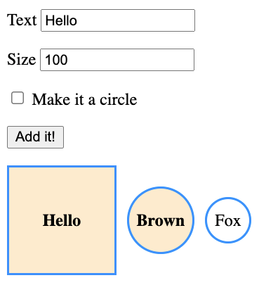
2. Whenever the form is submitted, add a <div> to the page.
   1. The new div will always have class "shape".
   2. The new div will display the text from the "Text" input.
   3. The new div will have width, height, and line-height CSS properties set to the "Size" input value with "px" unit.
   4. The new div will have an additional CSS class of "circle" if the "Make it a circle" checkbox is checked.
3. Add styling to the CSS file…
   1. For the "shape" class, add a border, display: inline-block, text-align: center, and 10px right margin.
   2. For the "circle" class, use border radius to make the shape appear as a circle.

The next page includes a screenshot of what the page might look like after submitting the form with several different values.

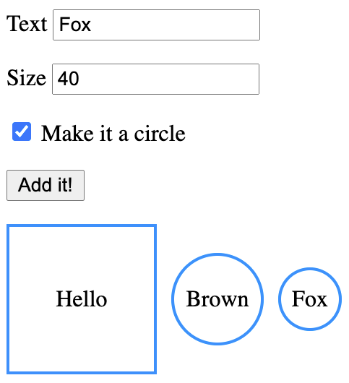

**Extended Challenges:**

1. When any of the shapes is clicked, toggle a "highlighted" class on that shape. Add a rule to the CSS file that changes the background-color and font-weight of shapes with the highlighted class.
2. Reset the form after each submit.

*Screenshot with "highlighted" and for reset extended challenges:*

